Selenium Grid Architecture:

Selenium Grid has a Hub and Node Architecture.

The Hub:

The hub is the central point where you load your tests into.

There should only be one hub in a grid.

The Nodes:

Nodes are the Selenium instances that will execute the tests that you loaded on the hub.

~~~ for HUB, use this command:

java -jar selenium-server-standalone-3.8.1.jar -role hub

~~~ for Node, use this command:

java -Dwebdriver.chrome.driver="/Users/NaveenKhunteta/Downloads/chromedriver" -jar selenium-server-standalone-3.8.1.jar -role node -hub http://192.168.0.102:4444/grid/register

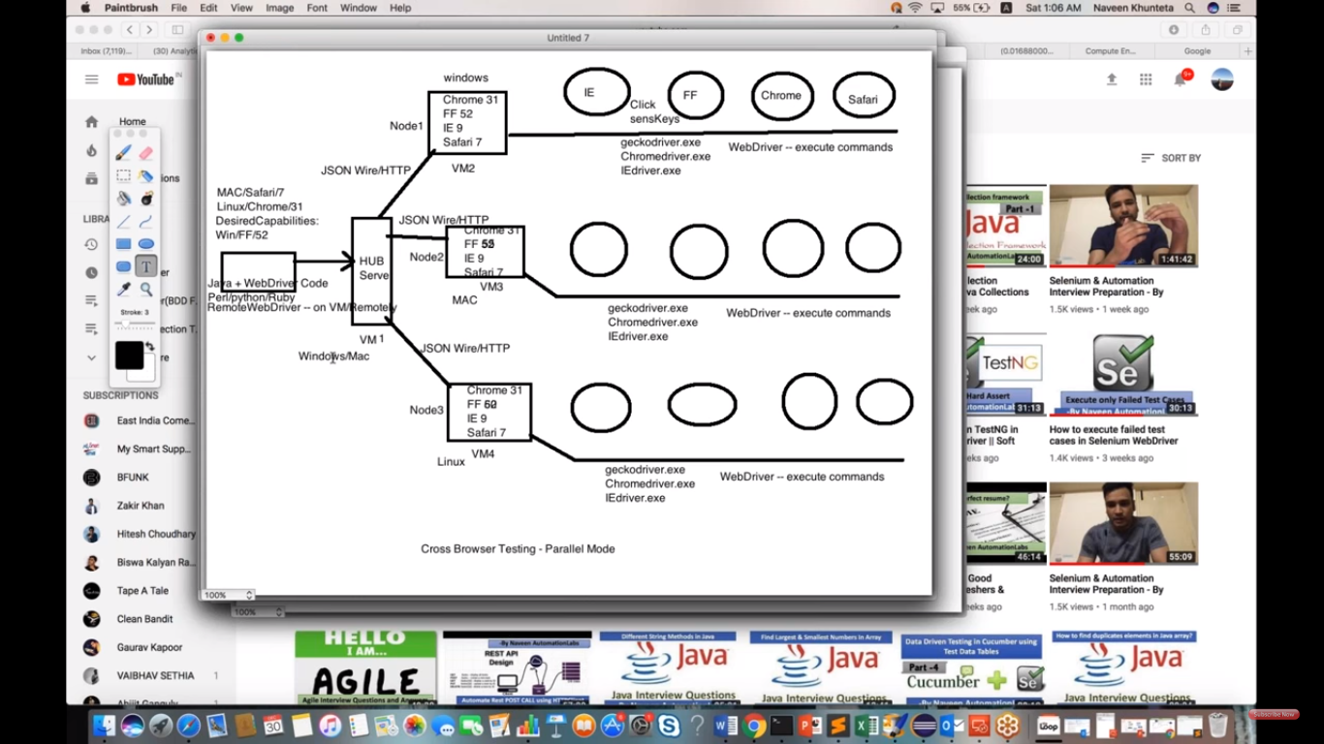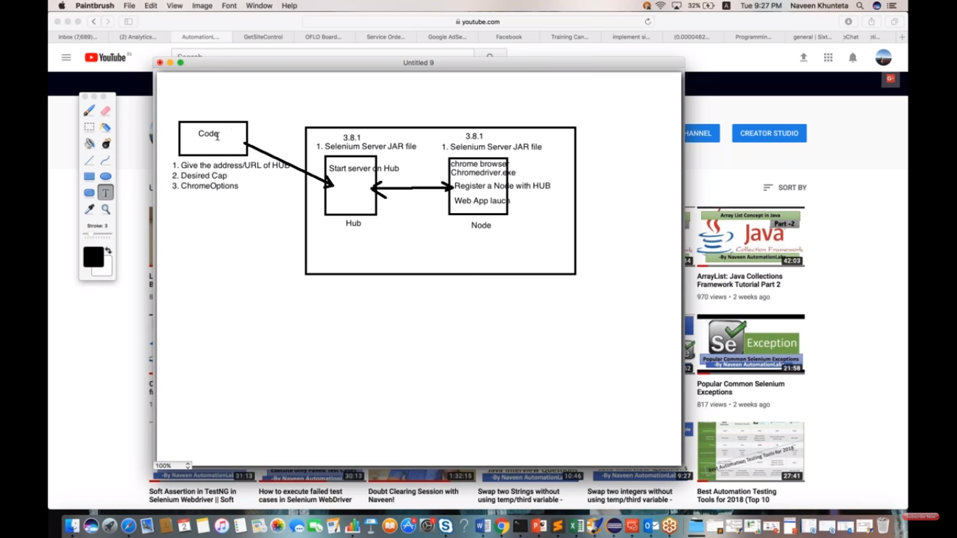

Open the folder where your Selenium Standalone jar file is available and than open command promt

Java –jar se and press tab key-it will give complete jar file than space -role hub and press enter

And don’t close cmd

Than open browser and type local host 4444

Again open new cmd and go to the folder where Selenium standalone jar is available

